DATA SCIENCE  DL-2001 | Lab 10  Association Rule Mining using the Apriori Algorithm on Retail Transaction Data

National University of Computer & Emerging Sciences – NUCES – Karachi

Course Code: DL-2001 | Data Science Lab

Objectives
- Understand Market Basket Analysis.
- Apply Apriori algorithm to find frequent itemsets.
- Generate association rules using Support, Confidence, and Lift.
- Use Python (mlxtend library) to analyze retail transaction datasets.
- Interpret association rules for business insights.

Association Rule Mining
Association Rule Mining finds interesting relationships (patterns) between items in large transaction databases.
{Bread} → {Butter}
This means: Customers who buy Bread are likely to buy Butter.

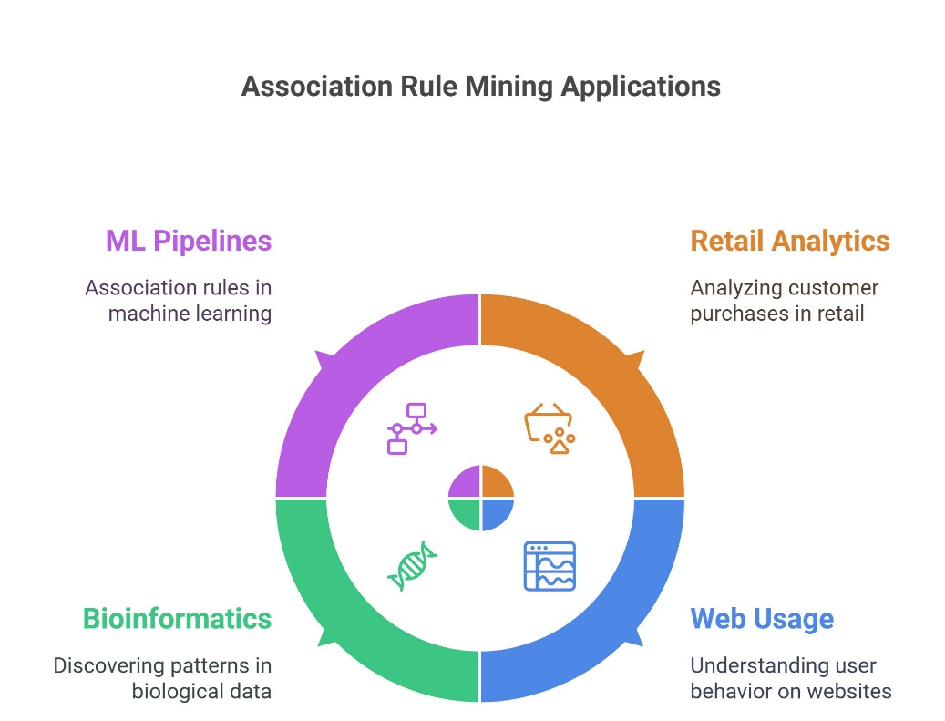

Important Metrics

(a) Support
Frequency of item(s) in all transactions.

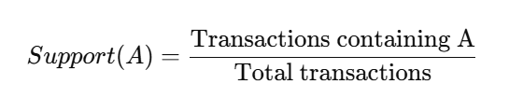
(b) Confidence
Strength of implication in the rule.
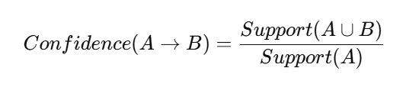

(c) Lift (dependency)
Measures how much B is dependent on A.
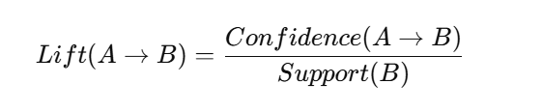
- Lift > 1: Strong positive association
- Lift = 1: No effect
- Lift < 1: Negative association

Apriori Algorithm – Steps
- Generate candidate itemsets of size 1 (C1)
- Filter them using minimum support → get frequent itemsets (L1)
- Use L1 to generate candidate itemsets of size 2 (C2)
- Again filter using support → get L2
- Repeat until no more itemsets
- Use frequent itemsets to generate association rules
Apriori relies on:
Anti-monotone property:
If an itemset is frequent, all its subsets must also be frequent.
Task1
Create 10–20 transactions.
Each transaction should have 3–5 items.
Suggested items: Milk, Bread, Butter, Eggs, Cheese, Juice.
Columns: ID ,items
Generate the dataset randomly using Python lists.
Convert the dataset into one-hot encoding using TransactionEncoder.
Apply Apriori Algorithm:
- Minimum support = 0.4
Generate association rules:
- Minimum confidence = 0.6
Sort rules by lift.
Interpret top 3 rules in business terms.
Task2
Generate 15–25 orders.
Each order contains 2–4 products.
Suggested products: Laptop, Mouse, Keyboard, Bag, Headphones, Charger.
Columns: order id and items
Generate random orders using Python.
the dataset using TransactionEncoder.
Apply Apriori Algorithm:
- Minimum support = 0.3
Generate association rules:
- Minimum confidence = 0.5
Sort rules by confidence.
Identify top product combinations useful for cross-selling.
Task3
Create 12–20 orders randomly.
Each order contains 2–4 menu items.
Suggested items: Pizza, Burger, Fries, Coke, Salad, Sandwich.
Columns: id , items
Generate random restaurant orders in Python.
Convert to one-hot encoded format using TransactionEncoder.
Apply Apriori Algorithm:
- Minimum support = 0.4
Generate association rules:
- Minimum confidence = 0.6
Display:
- Antecedent, Consequent, Support, Confidence, Lift
Suggest top 3 menu combos for marketing or meal deals.

